**Operators & Assignments**

Topics

1. Increment & Decrement Operators

2. Arithmetic Operators

3. String concatenation Operator

4. Relational Operators

5. Equality Operators

6. instanceof Operator

7. Bitwise Operators

8. Short circuit Operator

9. typecast Operator

10. Assignment Operators

11. Conditional Operators

12. new Operator

13. [] Operator

14. Operator precendence

15. new Vs newInstance()

16. NoClassDefFoundError Vs ClassNotFoundException

17. instanceof Vs isInstance()

**1. Increment & Decrement Operators**

> **Increment**

Pre - Increment Post - Increment

y = ++x; y = x++;

> **Decrement**

Pre - Decrement Post - Decrement

y = --x; y = x--;

|  |  |  |  |  |
| --- | --- | --- | --- | --- |
| **No.** | **Expression** | **Initial value of x** | **Value of y** | **Final value of x** |
| 1. | y = ++x | 10 | 11 | 11 |
| 2. | y = x++ | 10 | 10 | 11 |
| 3. | y = --x | 10 | 9 | 9 |
| 4. | y = x-- | 10 | 10 | 9 |

**Note**:

> Increment & Decrement operators can be applied only to the variables not to the constants.

e.g. int x = 10; int x = 10;

int y = ++x; //correct int y = ++10; // wrong

> Nesting of increment & decrement operator is not allowed.

e.g. int x = 10;

int y = ++(++x); // wrong

> We can apply increment & decrement operators to every primitive type except to Boolean.

> In case of increment & decrement operators, internal typecasting will be performed automatically.

i.e. b++ -> b = (type of b) (b + 1);

**2. Arithmetic Operators (+, - , *, /, %)**

> If we apply any arithmetic operator between 2 variable a & b, the result type is always

**Max (int, type of a, type of b)**

i.e. byte + byte = int; byte + short = int; byte + long = long; char + double = double;

char + char = int;

**> Infinity:** In Integral arithmetic (byte, short, int, long), there is no way to represent infinity, hence if infinity comes, we will get Arithmetic Exception.

But In floating point Arithmetic (float, double), there is a way to represent infinity. For this, Float & Double classes contain the following 2 constants: POSITIVE_INFINITY; NEGATIVE_INFINITY

Hence, even though result is infinity, we won’t get any Arithmetic Exception in floating point arithmetic.

e.g. System.out.println(10/0.0); // Infinity

System.out.println(-10/0.0); // -Infinity

**> NaN:** In Integral arithmetic (byte, short, int, long), there is no way to represent undefined results, hence if undefined comes, we will get Arithmetic Exception.

But In floating pint Arithmetic (float, double), there is a way to represent undefined. For this, Float & Double classes contain NaN constant.

Hence, even though result is undefined, we won’t get any Arithmetic Exception in floating point arithmetic.

e.g. System.out.println(0/0.0); // NaN

**> Arithmetic Exception**

- Runtime Exception

- Possible only in Integral Arithmetic.

- The only operators which cause Arithmetic Exception are / and %

**3. String concatenation Operator (+)**

> The only overloaded operator in Java is “+” operator. Sometimes it acts as Arithmetic addition operator & sometimes it acts as String concatenation operator.

> If at least one argument is String type, “+” operator acts as concatenation operator & if both arguments are numeric type then “+” operator acts as Arithmetic addition operator.

**4. Relational Operators (<, <=, >, >=)**

> We can apply relational operators for every primitive types except Boolean & Object types.

> Nesting of relational operators is not allowed otherwise we will get compile time error.

**5. Equality Operators (==, !=)**

> We can apply equality operators for every primitive type including Boolean type also.

> We can apply equality operators for Object types also but it’s reference comparison.

> If we apply equality operators for Object types then compulsory there should be some relation between argument types. (Either child to parent or parent to child or same type)

Q. Difference between == operator & .equals () method ?

Ans: In general, we use == operator for reference comparation & .equals () method for content comparison.

**6. instanceof Operator**

> We can use instanceof operator to check whether the given object is of particular type or not.

> Syntax: **r instanceof x**

where r is object reference & x is class name or interface name.

> To use instanceof operator, compulsory there should be some relation between argument types(Either child to parent or parent to child or same type).

> For any class or interface X, **null instanceof X** is always **false.**

**7. Bitwise Operators (&, |, ^)**

& -> AND -> Returns true if both arguments are true.

| -> OR -> Returns true if at least one argument is true.

^ -> XOR -> Returns true if both arguments are different.

e.g. true & false = false true | false = true true ^ false = true

> We can apply these operators to boolean types as well as integral types (byte, short, int, long)

e.g. 4 & 5 = 4; 4 | 5 = 5; 4 ^ 5 = 1;

**> Bitwise Complement Operator (~):-** We can apply this operator only for integral types but not for boolean types.

e.g. ~4 = -5 [MSB of ~4 is 1 so negative no. will be represented in 2’s complement]

**> Boolean Complement Operator (!):-** We can apply this operator only for boolean types.

e.g. !true = false;

**8. Short – Circuit Operator (&&, ||)**

> These are exactly same as Bitwise operator (&, |) except the following difference

|  |  |  |
| --- | --- | --- |
| No. | &, | | &&, || |
| 1. | Both arguments should be evaluated always. | Second argument evaluation is optional. |
| 2. | Relatively performance is low. | Relatively performance is high. |
| 3. | Applicable for both boolean & integral types. | Applicable only for boolean types not for integral types. |

**Case 1:** X && Y -> Y will be evaluated if X is true i.e. if X is false then Y won’t be evaluated.

**Case 2:** X || Y -> Y will be evaluated if X is false i.e. if X is true then Y won’t be evaluated.

e.g.

|  |  |  |
| --- | --- | --- |
| __ | x | y |
| & | 11 | 17 |
| && | 11 | 16 |
| | | 12 | 16 |
| || | 12 | 16 |

int x = 10, y = 15;

if (++x < 10 __ ++y > 15) {

x++;

} else {

y++;

}

**9. typecase Operator**

> There are 2 types of typecasting

a) Implicit typecasting

b) Explicit typecasting

a) Implicit typecasting (widening / upcasting)

> Compiler is responsible to perform implicit typecasting.

> Whenever we’re assigning smaller datatype value to bigger datatype variable, implicit typecasting will be performed.

> There is no loss of information in this typecasting.

> The following are various possible conversions where implicit typecasting will be performed.

byte short

int long float double

char

e.g. int x = ‘a’; System.out.println(x); // 97

double d = 10; System.out.println(d); // 10.0

b) Explicit typecasting (narrowing / downcasting)

> Programmer is responsible to perform explicit typecasting.

> Whenever we’re assigning bigger datatype value to smaller datatype variable then explicit typecasting is required.

> There may be a chance of loss of information in this typecasting.

> The following are various possible conversions where explicit typecasting will be performed.

byte short

int long float double

char

e.g. int x = 130; byte b = (byte) x; System.out.println(b); // -126

> Whenever we’re assigning bigger datatype value to smaller datatype variable by explicit typecasting, the MSB(Most significant bit) will be lost, we have to consider LSB.

> If we assign floating point values to the integral types by explicit typecasting, the digits after the decimal points will be lossed.

**10. Assignment Operators**

> There are 3 types of Assignment operators:

a) Simple Assignment: e.g. int x = 10;

b) Chained: e.g. int a, b, c, d; a = b = c = d = 20;

c) Compound Assignment operators:

> The following are all possible compound assignment operators in Java

|  |  |  |
| --- | --- | --- |
| +=  -=  *=  /=  %= | &=  |=  ^= | >>= (right shift)  >>>= (unsigned right shift)  <<= (left shift) |

> In case of Compound Assignment, internal typecasting will be performed automatically.

e.g. byte b = 10; b += 1 means b = (byte) (b + 1)

**11. Conditional Operators (? :)**

> The only possible ternary operator in Java is Conditional operator.

> Syntax: int x = (10 < 20) ? 30 : 40; // 30

> We can perform nesting of conditional operator also.

**12. new operator**

> We can use new operator to create Object.

e.g. Test t = new Test();

> After creating an object, constructor will be executed to perform initialization of Object, hence constructor is not for creation of object & it is for initialization of an object.

> In Java, we have only new keyword but not delete keyword because destruction of useless objects is the responsibility of Garbage Collector.

**13. [] operator**

> We can use this operator to declare & create arrays.

e.g. int[] x = new int[10];

**14. Java operator precedence and Associativity**

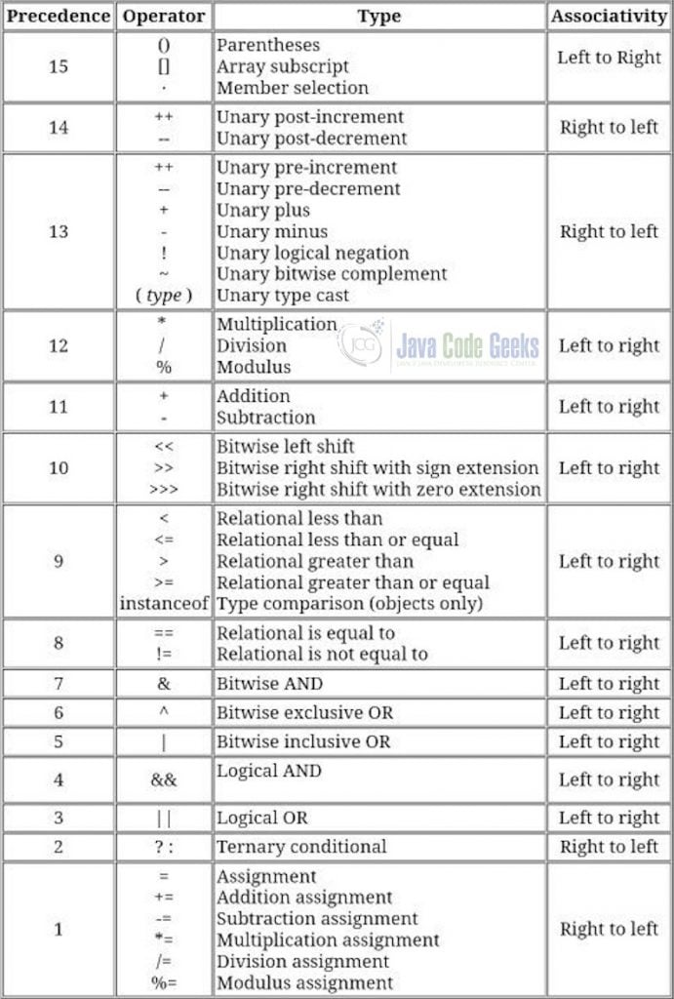

**15. new Vs newInstance()**

|  |  |  |
| --- | --- | --- |
| **No** | **new** | **newInstance()** |
| 1. | It is operator in Java | It is a method in java.lang.Class |
| 2. | We can use new operator to create an object if we know class name at the beginning. | We can use newInstance() method to create object if we don’t know class name at the beginning & it is available dynamically at runtime. |
| 3. | To use new operator class not required to contain no-arg constructor. | To use newInstance() compulsory class should contain no-arg constructor otherwise we will get RuntimeException saying **InstantiationException** |
| 4. | At runtime if .class file not available then we will get Runtime Exception saying **NoClassDefFoundError**. | At runtime if .class file not available then we will get Runtime Exception saying **ClassNotFoundException**. |
| 5. | E.g.  Test t = new Test(); | E.g.  Object o = Class.forName(args[0]).newInstance() |

**16. NoClassDefFoundError Vs ClassNotFoundException**

|  |  |  |
| --- | --- | --- |
| **No** | **NoClassDefFoundError** | **ClassNotFoundException** |
| 1. | For hardcoded class names, at runtime if the corresponding .class file is not available then we will get runtime exception saying NoClassDefFoundError. | For Dynamically provided class names, at runtime if the corresponding .class file is not available then we will get runtime exception saying ClassNotFoundException. |
| 2. | It is unchecked exception | It is checked exception. |
| 3. | Test t = new Test(); | Object o = Class.forName(args[0]).newInstance() |

**17. instanceof Vs isInstance()**

|  |  |  |
| --- | --- | --- |
| **No** | **Instanceof** | **isInstance()** |
| 1. | Instanceof is an operator in Java. | isInstance() is a method present in java.lang.Class |
| 2. | We can use instanceof to check whether the given object is of particular type or not & we know the type at the beginning. | We can use isInstance() method to check whether the given object is of particular type or not & we don’t know the type at the beginning & it is available dynamically at runtime. |
| 3. | E.g.  Thread t = new Thread();  t instanceof Runnable // true  t instanceof Object // true | E.g.  Thread t = new Thread();  args[0] = String  Class.forName(args[0]). isInstance(t) //false |